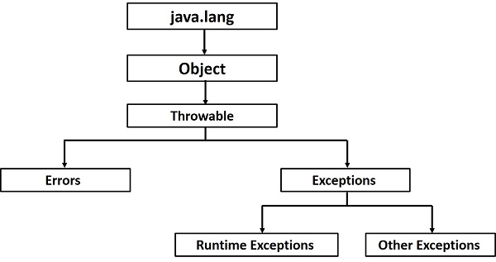

**# checked vs. unchecked exception**

**In C++, all exceptions are unchecked, so it is not forced by the compiler to either handle or specify the exception.**

**In Java exceptions under Error and RuntimeException classes are unchecked exceptions, everything else under throwable is checked.**

**# which one to use**

**Rule is if a client can reasonably be expected to recover from an exception, make it a checked exception. If a client cannot do anything to recover from the exception, make it an unchecked exception.**